Virtual Hot Corners Design:

My program seeks to bridge the barrier between traditional human computer interaction. Traditionally, all input requires physical contact with the computer, whether it be from the keyboard/trackpad/mouse. Virtual Hot Corners seeks to provide a way from computer users to easily and accurately launch user-defined programs by placing their hands on one of the four “virtual buttons” that my program detects for. This can be efficient, as rather than having to do multiple clicks to hide away currently open windows to find shortcuts, a simple hand motion will launch the desired action.

First, my program takes in the raw video input from the webcam. Then, it applies filters to make skin colors more prevalent. (The code for this filtering was not developed by me, and the source is provided in the source.txt file). The rest of my code was developed to take analyze the images provided from the filter. First, my program crops four corners from the filtered image. Then, my program sorts the RGB values from each corner, assigning each pixel either to Black/White depending on the RGB value. Then, if a certain percentage of each corner is the color white, the corner is marked as True, or active. Then, if it is registered True for a certain amount of time, an action is launched.

I have made many changes and improvements to my Graphical User Interface. I based my GUI based off my experience using computer programs, and organized the various elements in a way that represents a slick and clean UI experience.

Here are a few pictures showing the progression of the GUI.

Version 1: (Humble Beginnings)

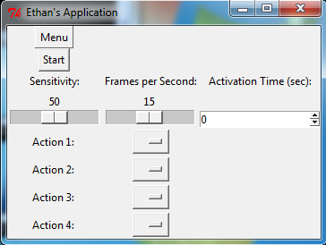

Version 2: (Added more options as functionality increased)

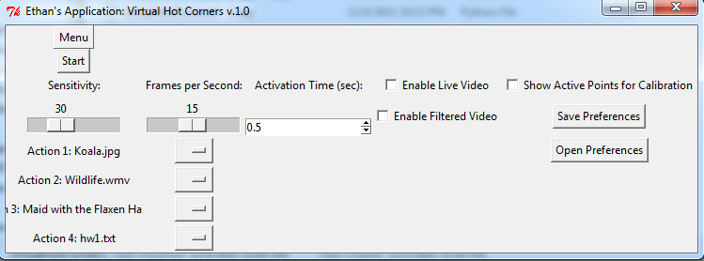

Version 3: (Reorganized, made start button a lot bigger)

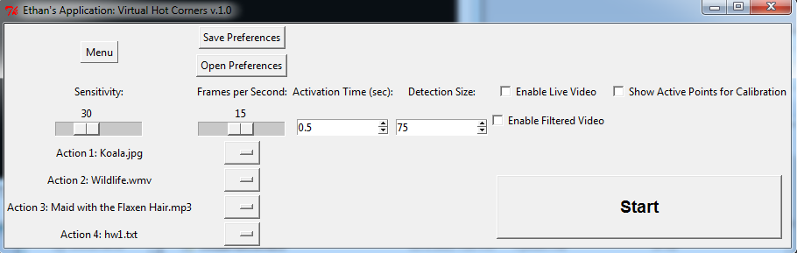

Final Version: (More Options, Icons representing file type)

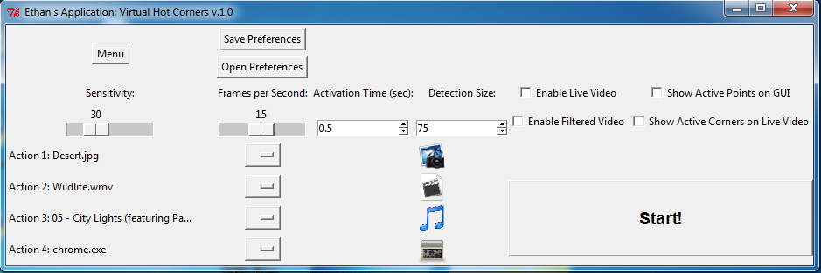

Head CA Will testing/giving feedback

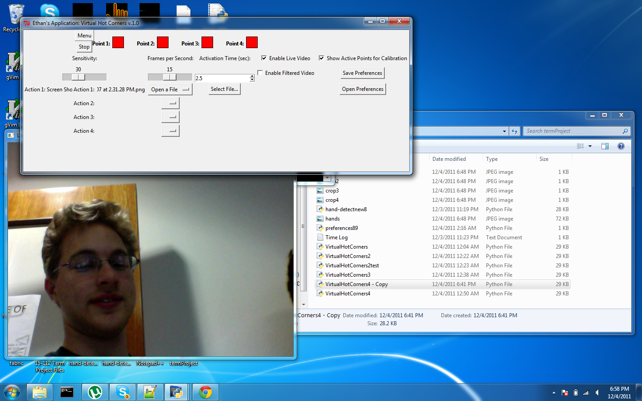

Using Final Version! Note video overlay!

